Year 8 Biology- What do I know?

What is a unicellular organism? Give an example.

What is a multicellular organism? Give an example.

Label the organelles in the **animal cell** below

Word bank- Nucleus Mitochondria Cell membrane Ribosome DNA Nucleolus Cytoplasm

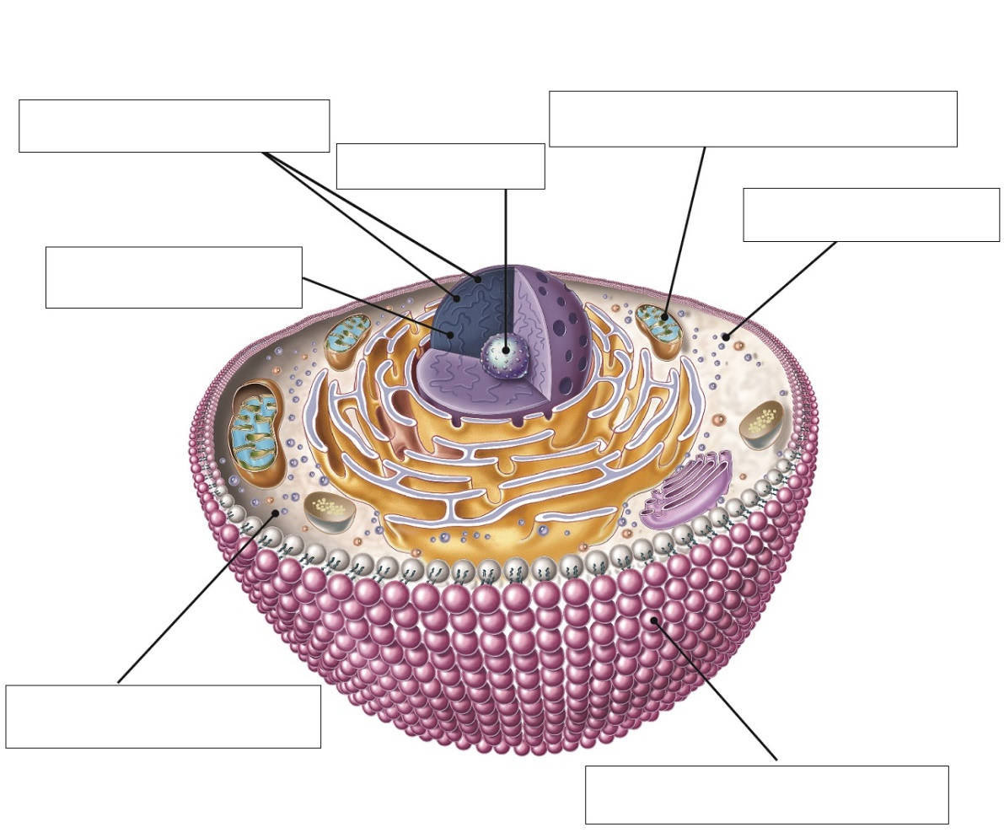

The words listed below are incomplete. Using the clues provided, find the words in the puzzle to complete each word

|  |  |  |  |  |  |  |  |  |  |  |  |  |  |
| --- | --- | --- | --- | --- | --- | --- | --- | --- | --- | --- | --- | --- | --- |
| L | L | E | C | | E | L | O | U | C | A | V | | S |
| V | I | R | U | | S | I | A | R | O | L | F | | U |
| D | B | I | N | | E | G | O | H | T | A | P | | R |
| L | O | S | U | | O | I | T | C | E | F | N | | I |
| O | D | A | S | | Y | M | P | T | O | M | S | | V |
| C | Y | U | I | | B | A | C | T | E | R | I | | A |
| S | E | M | O | | S | O | B | I | R | D | N | | A |
| WORD | | | | CLUE | | | | | | | |
| _ E L _ | | | | Each of these has a nucleus. | | | | | | | |
| R_ _ _ _ _ _ _ | | | | This is where protein is produced within a cell. | | | | | | | |
| D_ _ | | | | This carries genetic information in each person. | | | | | | | |
| C_ _ _ | | | | A common type of virus. | | | | | | | |
| B_ _ _ | | | | Harmful viruses can invade the human _ _ _ _. | | | | | | | |
| B_ _ _ _ _ _ _ | | | | These have cell walls and contain DNA, but do not have a nucleus. | | | | | | | |
| V_ _ _ _ | | | | Scientists consider this to be a non-living pathogen. | | | | | | | |
| F_ _ _ _ | | | | The microbes that live on our bodies are natural _ _ _ _ _. | | | | | | | |
| S_ _ _ _ _ _ _ | | | | These changes occur to a person as a consequence of disease. | | | | | | | |
| V_ _ _ _ _ _ _ | | | | The space within the cytoplasm of a cell. | | | | | | | |
| P_ _ _ _ _ _ _ | | | | This is a microorganism that can potentially cause disease. | | | | | | | |
| I_ _ _ _ _ _ _ _ _ | | | | _ _ _ _ _ _ _ _ _ _ diseases may pass from one organism to another. | | | | | | | |

On the lines to the right of each diagram, list the organs involved in each system using the list below.

|  |  |  |  |  |  |
| --- | --- | --- | --- | --- | --- |
| *Brain* | *Nose* | *Muscles* | *Blood* | *Stomach* | *Mouth* |
| *Lungs* | *Small intestine* | *Heart* | *Diaphragm* | *Oesophagus* | *Large intestine* |
| *Liver* | *Veins* | *Spinal cord* | *Windpipe* | *Bones* | *Nerves* |
|  | |  | |  | |
| SKELETAL SYSTEM | | NERVOUS SYSTEM | | CIRCULATORY SYSTEM | |
|  | |  | |  | |
|  | |  | |  | |
| RESPIRATORY SYSTEM | | DIGESTIVE SYSTEM | | MUSCLE SYSTEM | |

True or false

Read the statement and circle whether it is true or false.

a The heart is about the size of your fist. T or F

b Valves keep the blood moving in the right direction. T or F

c Oxygen is carried by white blood cells. T or F

d Red blood cells kill bacterial cells. T or F

e Platelets are cell fragments that fix blood vessels. T or F

f Capillaries are the largest blood vessels. T or F

g Arteries are only one cell thick. T or F

Matching meaning

Draw a line to match the organ (on the left) with the appropriate description of its function (on the right).

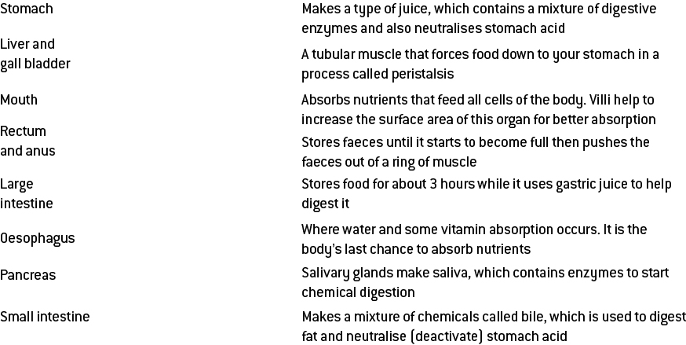

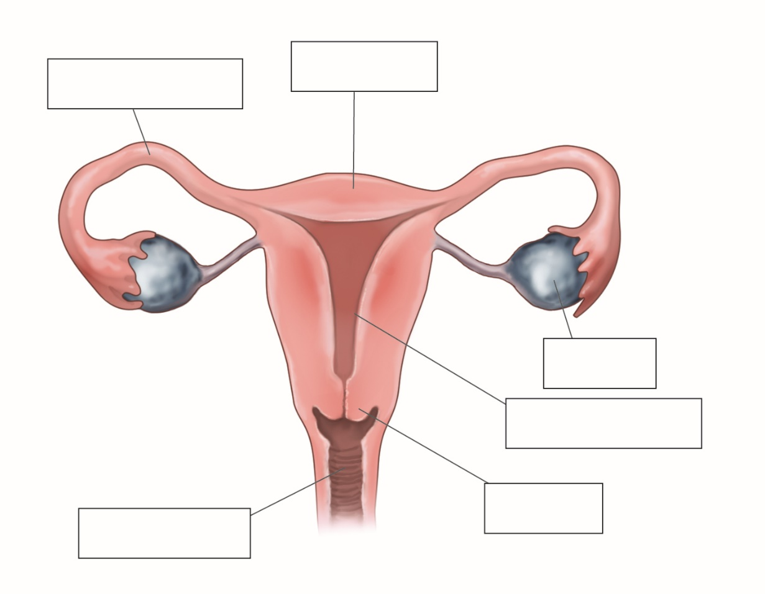Label the following diagram of the human female reproductive system.